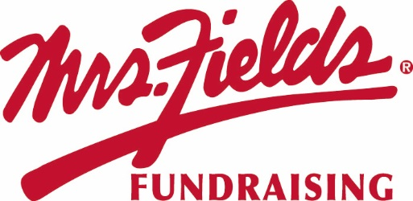

Please support our
GROUP NAME
Your Sale Starts Today!! | Pick Up Information:
Sale Ends: DATE  Order Form and Money Due | After all the orders have been placed all families will received pickup information

HOW TO HELP?
* Show the catalog to friends, relatives and co-workers.
* Please, no unsupervised door-to-door selling.
* Please collect payment when you take the order. (No Tax)

HOW IT WORKS…
Order on Paper
1. Make checks payable to GROUP NAME.
2. Use the order form to keep track of the orders you are collecting.
2. Please fill out your envelope completely with your name, teacher, class and phone number.
3. Please turn in the envelope only, filled out completely with money enclosed. Keep the order form for your records.

We are raising money for: Type your group’s goal here…
Individual Goal: | XX Number of Items
Group Goal: | $ X,XXX

If you have questions please contact: (Organizer Contact Information).

FUNDRAISER NOTES

